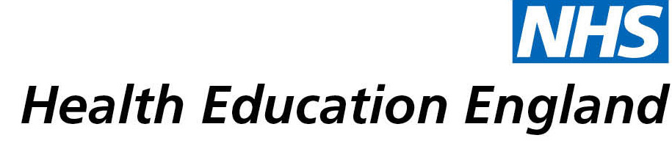

# Library and Knowledge Services case study

# *Gloucestershire Hospitals NHS Foundation Trust: The best evidence to enable a successful business case*

21 February 2022

## Reason for enquiry

Evidence was needed to write a business case for funding for a prehabilitation service for cancer patients and specifically to discover what outcome measures were appropriate to measure the success of this pilot project.

## What the knowledge and library specialist did

Librarian Camila Garces-Bovett conducted a synthesised Evidence Search. An evidence search is when the best and most appropriate information is found by a librarian using specialised searching techniques and resources. The information is then summarised and presented in a format which makes it easier and quicker for the clinician to read.

A range of good quality resources were searched including healthcare research databases Embase and PubMed . A scoping search of the internet was conducted and Google Scholar was used for prospective citation search. A variety of good quality research articles and guidelines were found. The evidence was summarised and sent three weeks ahead of the requested deadline.

# Impact of input from the library and knowledge service

Having the best evidence, provided by librarians, enabled the successful creation of a business case, securing funding for a pilot prehabilitation cancer service and has ensured the best outcome measures will be used to evaluate the project.

## Immediate Impact

“We used this research to help write the business case which enabled us to secure funding for a two year project”

“this [literature search] helped us to identify which outcomes measures we should use as part of project plan”

“Development of the service with robust outcomes measures [was] in place from day 1”

“We now provide physio, dietetic and psychological interventions to newly diagnosed cancer patients to support them through their cancer treatments”

“We offer preparation for cancer treatment and ongoing self-management strategies, meaning patients are able to take control of aspects of their care at a time when many other aspects of their treatment journey are out of their control. We have lots of positive patients feedback and stories to date and we are only a few months in.”

The Library and Knowledge Service saved “approximately 10 hours” of clinical time.

## Probable future Impact

“Our hopes based on the data so far is we can use the outcome measures sourced via this literature review to prove that we can increase patients health and well-being through our interventions whilst also reducing in-patient bed days and oncology appointments. Leading to an overall cost saving to the organisation”

“This should reduce risks of patients suffering long term effects of cancer treatments whilst also reducing surgery risks. It will also contribute to patients long term health outcomes, making them less susceptible to other conditions such as diabetes or going on to develop other cancers”

## Submission by:

Juliette Sherrington – Allied Health Professionals Cancer Lead

## For further information on how you can get similar support contact your local NHS library and knowledge service.

**Submission Details**

***[To be completed by Knowledge and Library Service at the point of submission]***

**Name of Organisation**

**Gloucestershire Hospitals NHS Foundation Trust**

**Knowledge and Library Service Contact Email:**[lisa.riddington@nhs.net](mailto:lisa.riddington@nhs.net)

**Title of Case Study**

**NHS Region** *[Make bold the option which applies:]*

East of England

London

Midlands

North East and Yorkshire

North West

South East

**South West**

**Sector** *[Make bold the option which applies:]*

**Acute**

Acute and community

Care Trust

Clinical Commissioning Group

Commissioning Support

Community Trust

Cross-sector

Local Education and Training Board

Mental Health

Mental Health / Learning Disability

Mental Health / Social Care

Primary Care

Public Health

Shared Service / Informatics

Special HA

Other. If other, please specify

**Group Impacted** *[Make bold the option which applies:]*

Additional Clinical Services

Administrative and Clerical

**Allied Health Professionals**

Estates and Ancillary

Healthcare Scientists

Medicine and Dental

Multiprofessional

Patients, Carers and the Public

Nursing and Midwifery

Scientific and Technical

Students

**Impact Types** *[Make bold any of the impact types below which apply]*

Contributed to personal or professional development

**Contributed to service development or delivery**

Facilitated collaborative working

Health Information for Patients, Carers and the Public

**Improved the quality of patient care**

Mobilising evidence and organisational knowledge

**More informed decision making**

Productivity and efficiency

**Reduced risk or improved safety**

Saved money or contributed to financial effectiveness

Improved health and wellbeing of staff and learners

**Consent**

I have consent from individuals referred to in this case study to share details nationally for advocacy and promotion. *[Make bold the option which applies:]*

**Yes**

No